IMPORTANT NOTE:-

WE HAVE CREATED THE PROJECT TARS CARS SUCCESSFULLY USING HTML, CSS, JS (FRONTEND) AND DJANGO, SQLLITE(BACKEND)

IN THIS PROJECT WE HAVE MAINLY 3 SECTIONS

1. SIGN-UP/SIGN-IN PAGE

2. MAIN DASHBOARD

3. REGISTRATION FORM

IT COVERS ALL THE ASPECTS AND SPECIFICATIONS AS A CAR SERVICE WEBSITE NEEDS TO HAVE.

WE HAVE CREATED THIS PROJECT FROM SCRATCH AND ALL THE FRONTEND AND BACKEND CODING IS TOTALLY DONE BY OUR TEAM BRO CODERZ

THE PROJECT IS SUCCESSFULLY RUNNING IN LAPTOP/PC. BUT UNFORTUNATELY WE WERE NOT ABLE TO CREATE LIVE LINK IN GITHUB, BUT WE HAVE SUCCESSFULLY SUBMITTED OUR PROJECT IN THE REPOSITORY.

SO PLEASE CONSIDER OUR REQUEST AND EVALUATE OUR PROJECT CORRECTLY,

LINK:-[ PASTE THE REPOSITORY LINK HERE ABHI]

FOR VIEWING/RUNNING THE PROJECT FOLLOWING ARE THE STEPS TO BE FOLLOWED:-

1) Make sure Python and Django is installed in your system,

if not, then install python from the official website and in command prompt or any terminal of text editor, type the following command to install Django-

$pip install django

2) Open the project in the Text Editor and travel to it's root directory

3) Type the command $python manage.py runserver to run the localhost server.



4) After running the above command, the locahost server will be opened in the browser and the index.html page of the project will be shown, as in below

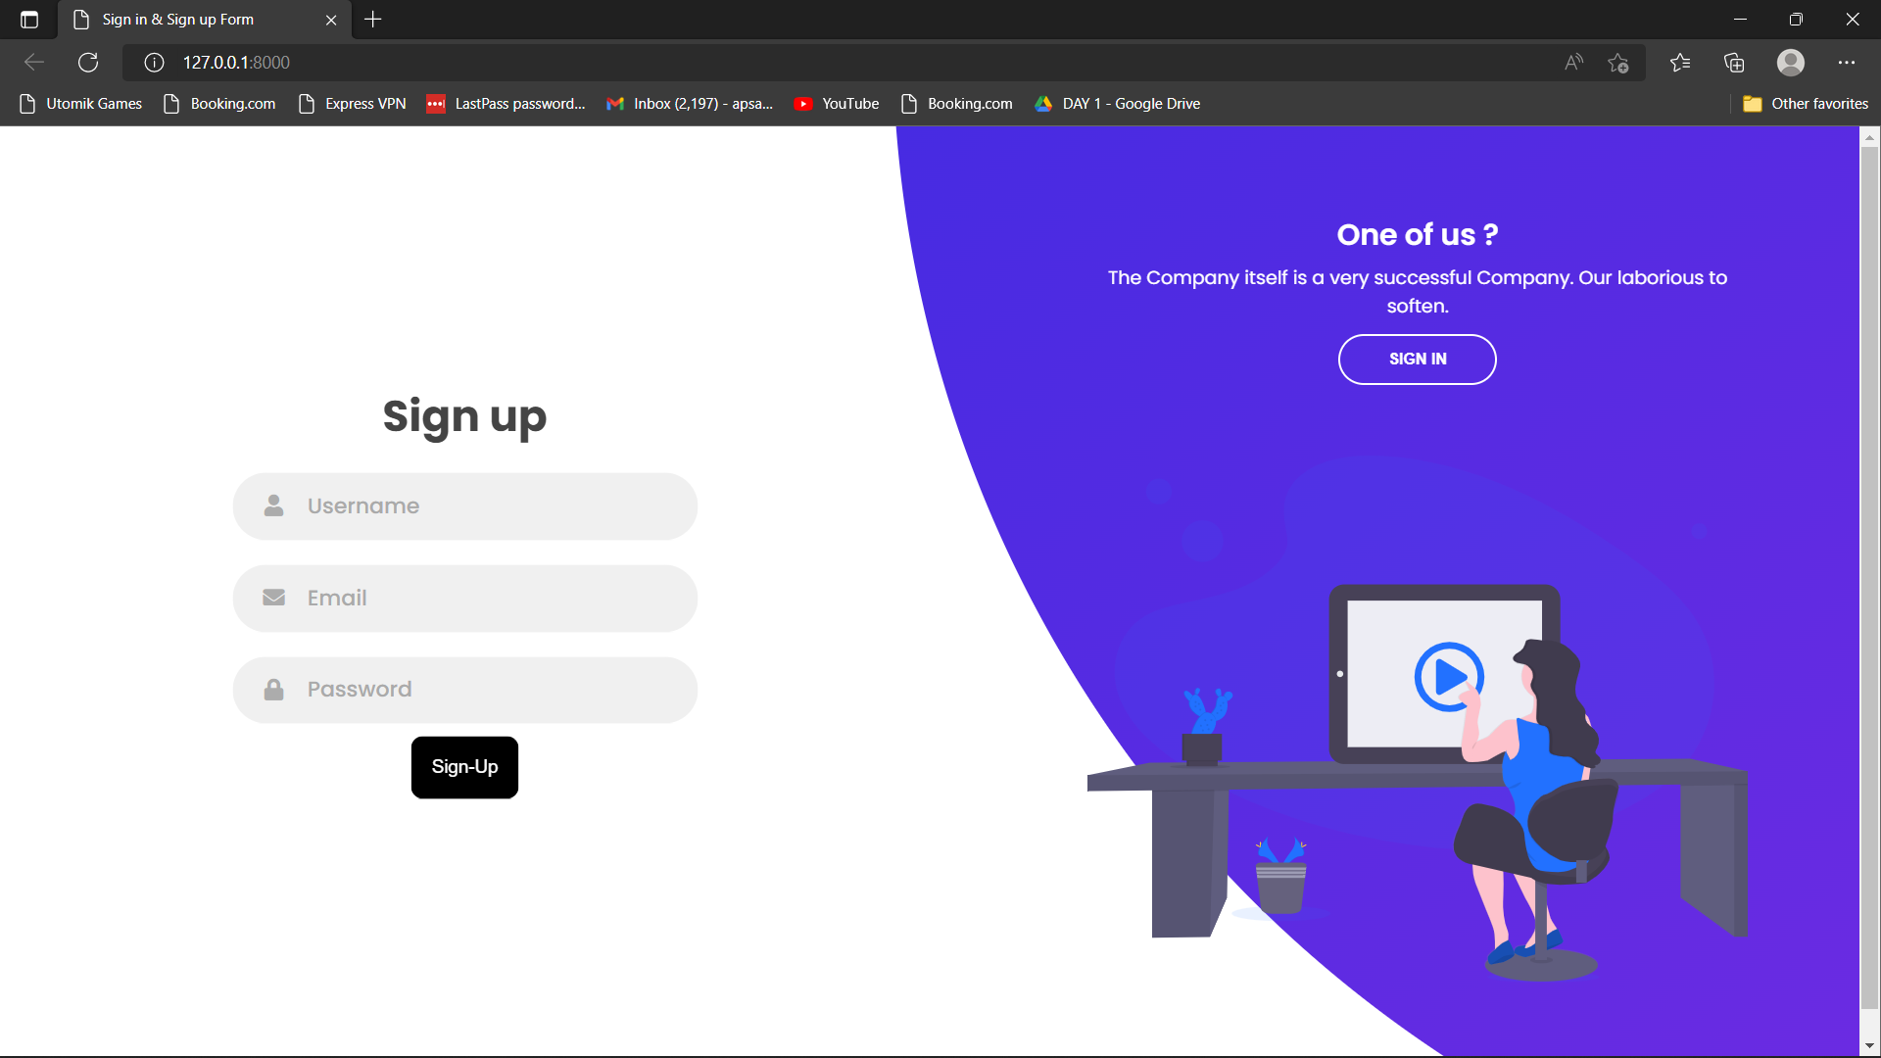

5) Type in required credentials and click Sign-up to create an account, then youll be redirected to Sign-in page, as shown below

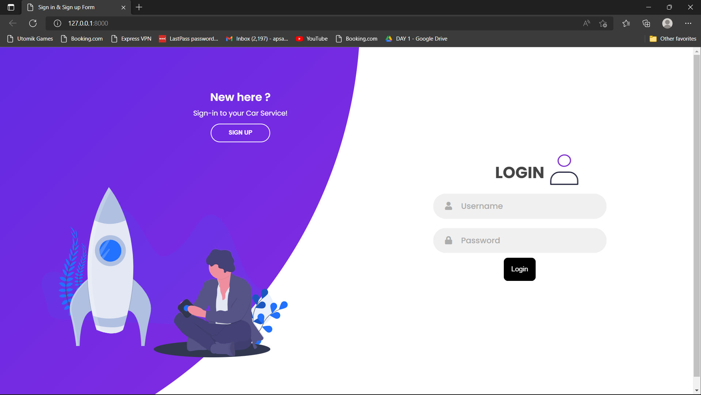

6)Type in proper credentials to Log in to the website, afterwards youll be able to view the homepage dashboard, as in below

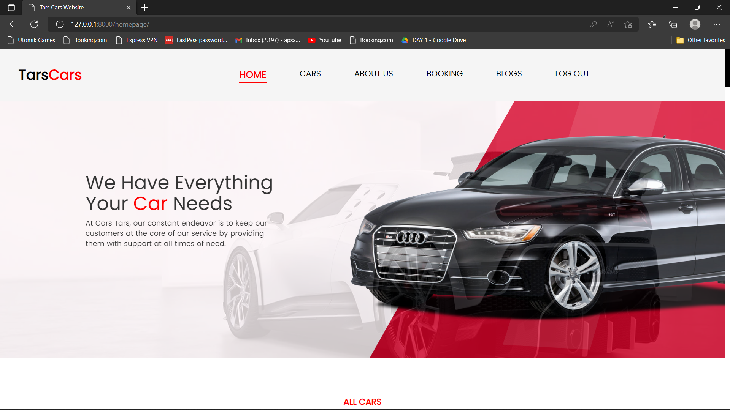

7) Click on bookings tab at the top to book your car service, then you’ll be redirected to car service booking form

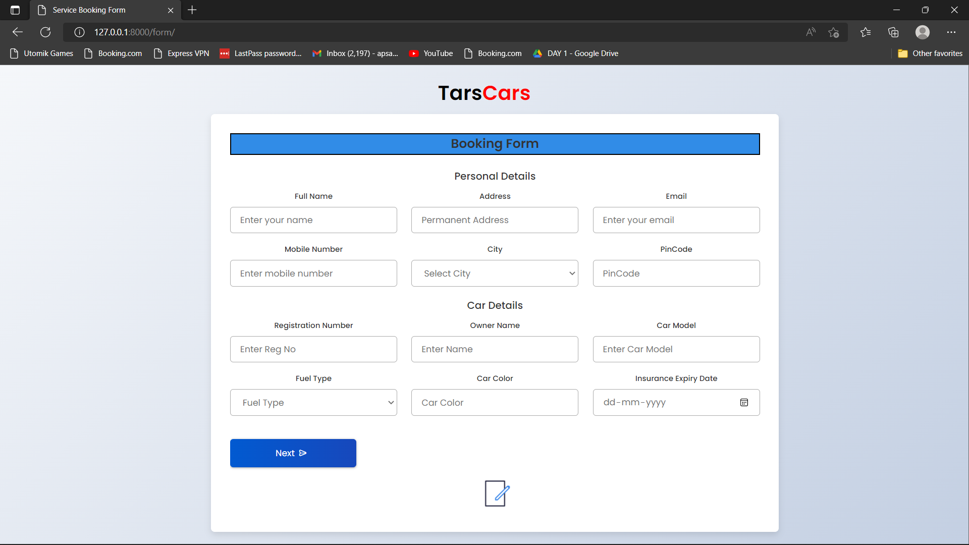

8) Fill in the required fields of the form and click submit to submit the form data. When submitted, you will receive a pop-up message saying “Thank You”

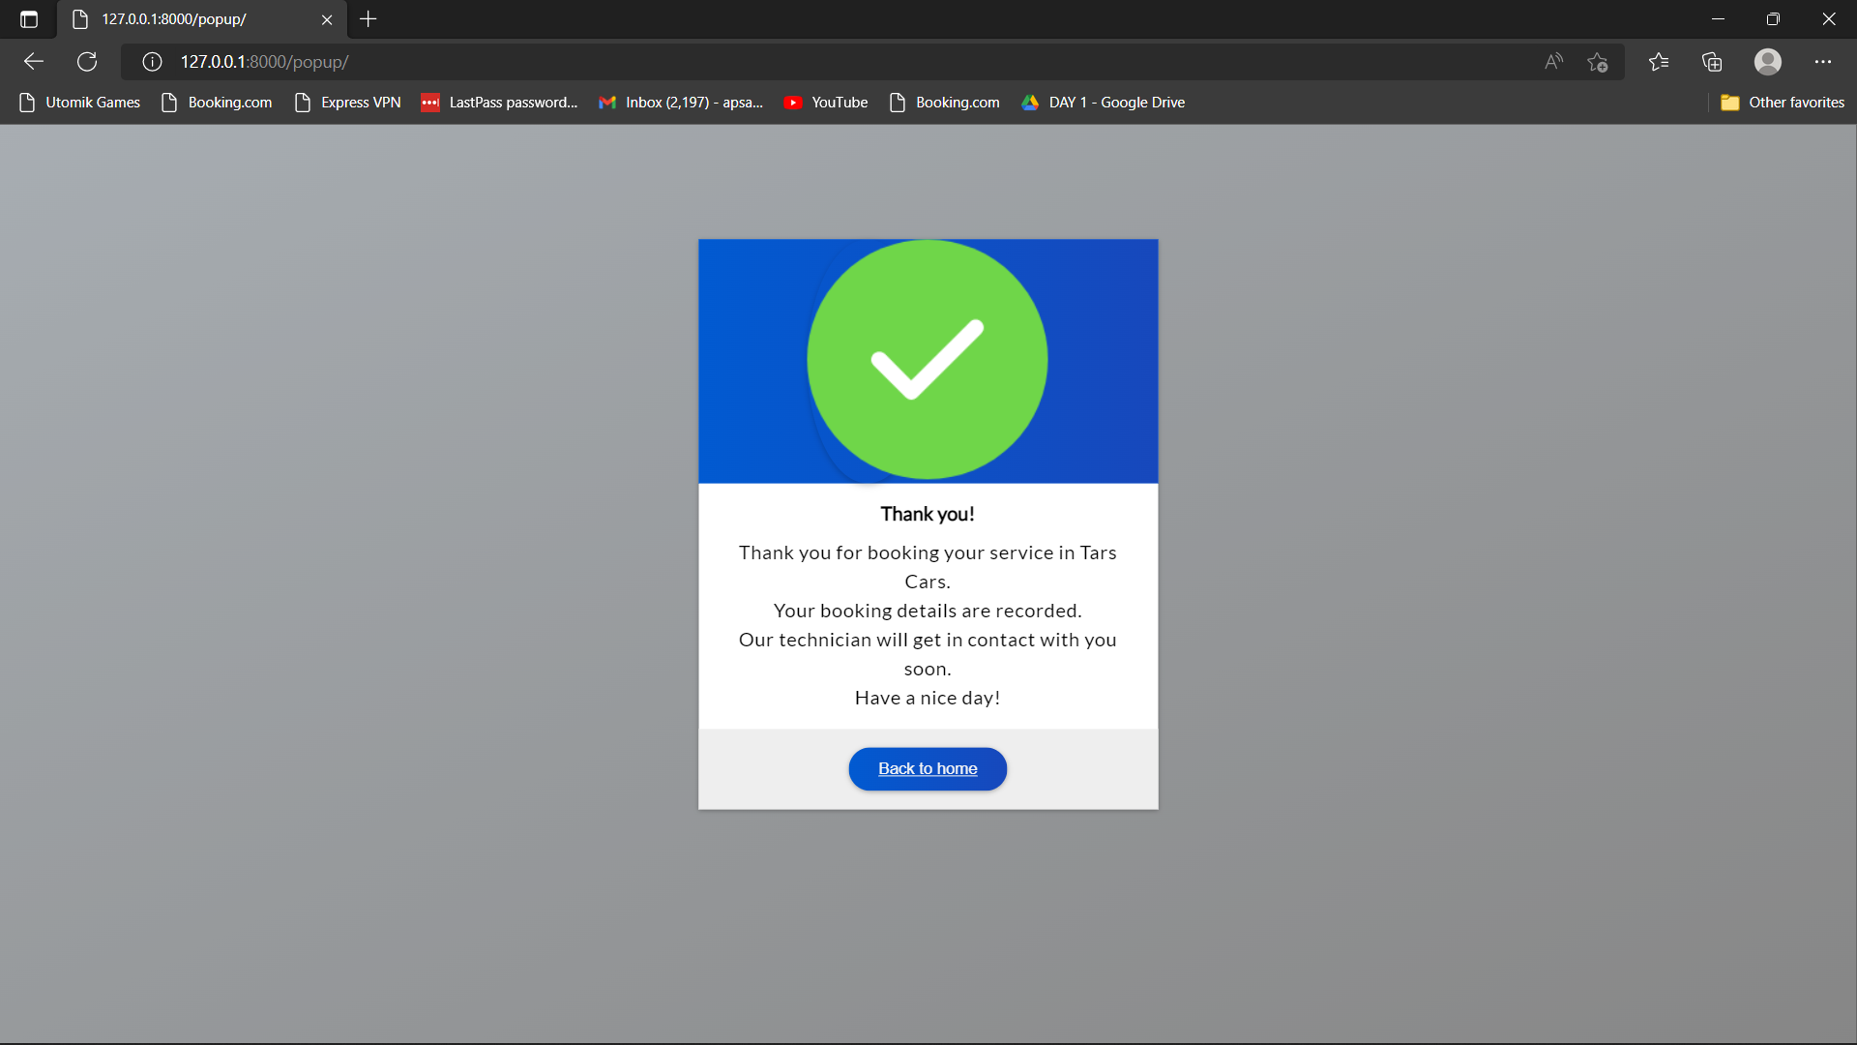

9) Then you are free to go aback to homepage and then logout of the website.

THANK YOU